**MONGOFB 10TH JUNE**

**Delecting BSON DOUMENTS**

package connection;

import java.util.Scanner;

import org.bson.Document;

import com.mongodb.client.FindIterable;

import com.mongodb.client.MongoClient;

import com.mongodb.client.MongoClients;

import com.mongodb.client.MongoCollection;

import com.mongodb.client.MongoDatabase;

import com.mongodb.client.model.Filters;

import com.mongodb.client.model.Updates;

public class deletebson{

public static void main(String[] args) {

Scanner sc=new Scanner(System.*in*);

MongoClient mongoClient = MongoClients.*create*("mongodb://localhost:27017");

MongoDatabase database = mongoClient.getDatabase("vit");

System.*out*.println("enter which column which you have");

String a=sc.nextLine();

System.*out*.println("enter which row you want to update");

String b=sc.nextLine();

// Get the collection

MongoCollection<Document> collection = database.getCollection("sales");

collection.deleteMany(Filters.*eq*(a,b));

//collection.deleteOne(Filters.eq(a,b));

System.*out*.println("Document deleted");

FindIterable<Document> Documents= collection.find();

for(Document document: Documents){

System.*out*.println(document);

}

}}

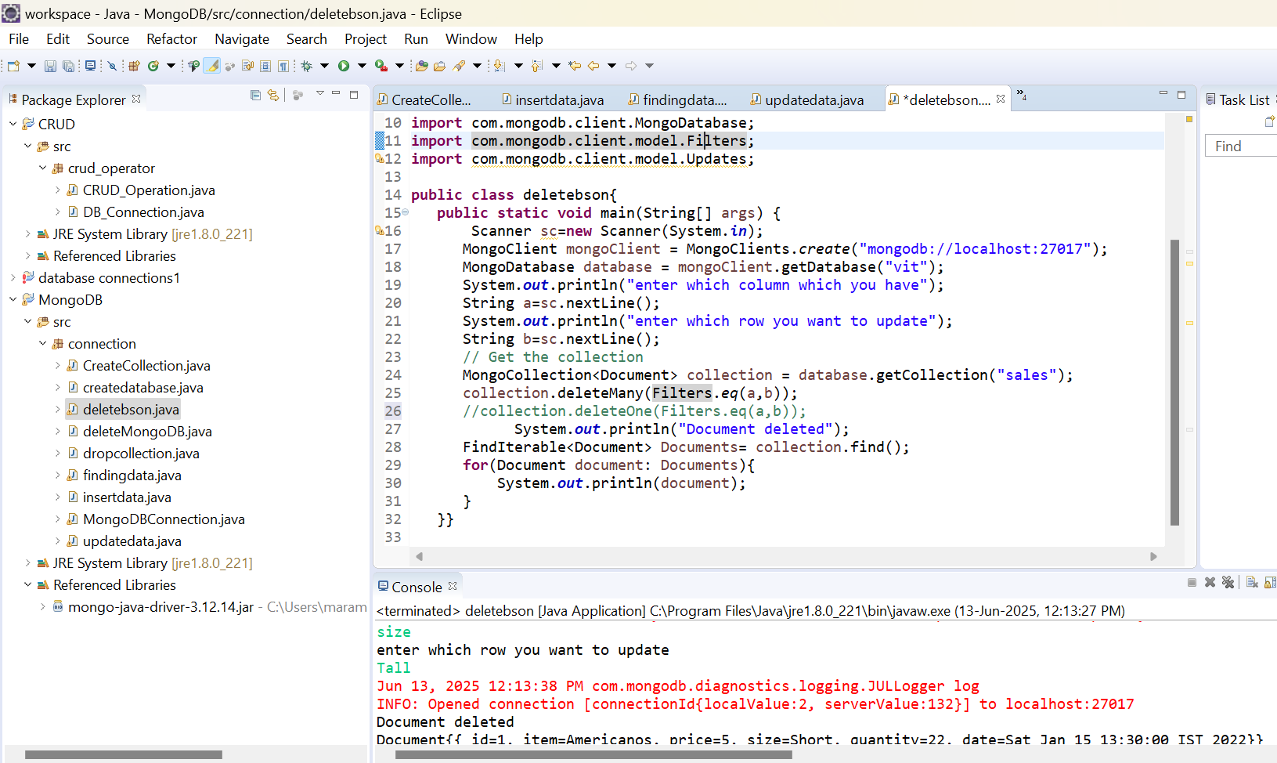

**LIMIT AND SKIP**

FindIterable<Document> documents=collection.find().limit(5).skip(3);

**for**(Document document:documents){

System.***out***.println(document);

}

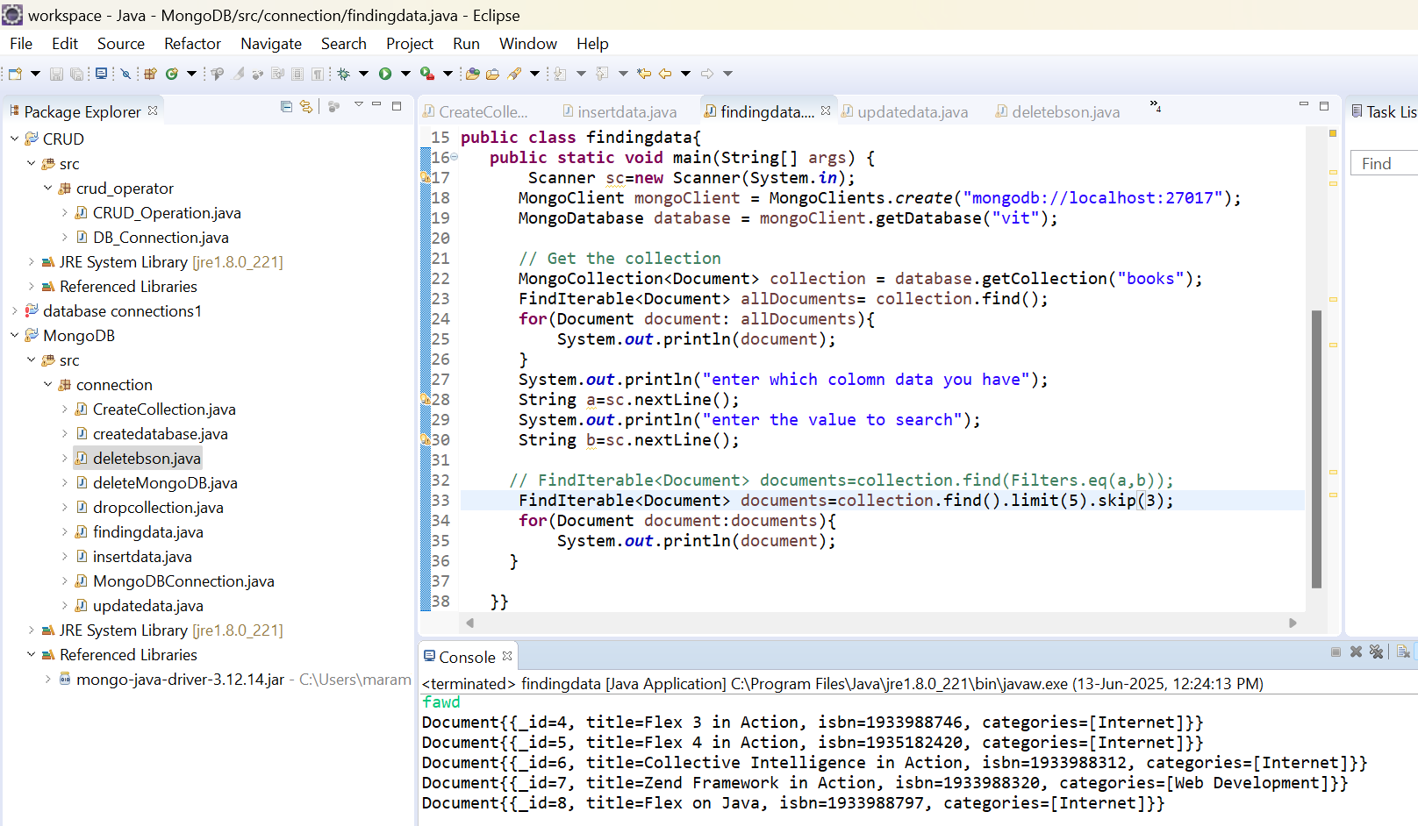

**SORTING**

MongoDatabase database = mongoClient.getDatabase("vit");

// Get the collection

MongoCollection<Document> collection = database.getCollection("sales");

System.***out***.println("descending order");

FindIterable<Document> allDocuments= collection.find().sort(**new** BasicDBObject("price",-1));

**for** (Document document : allDocuments) {

System.***out***.println(document);

}

System.***out***.println("Ascending order");

allDocuments= collection.find().sort(**new** BasicDBObject("price",1));

**for**(Document document: allDocuments){

System.***out***.println(document);

} 